Created 1 bucket for storing data
Created a bucket with 2 folders, pdf and pdf-text
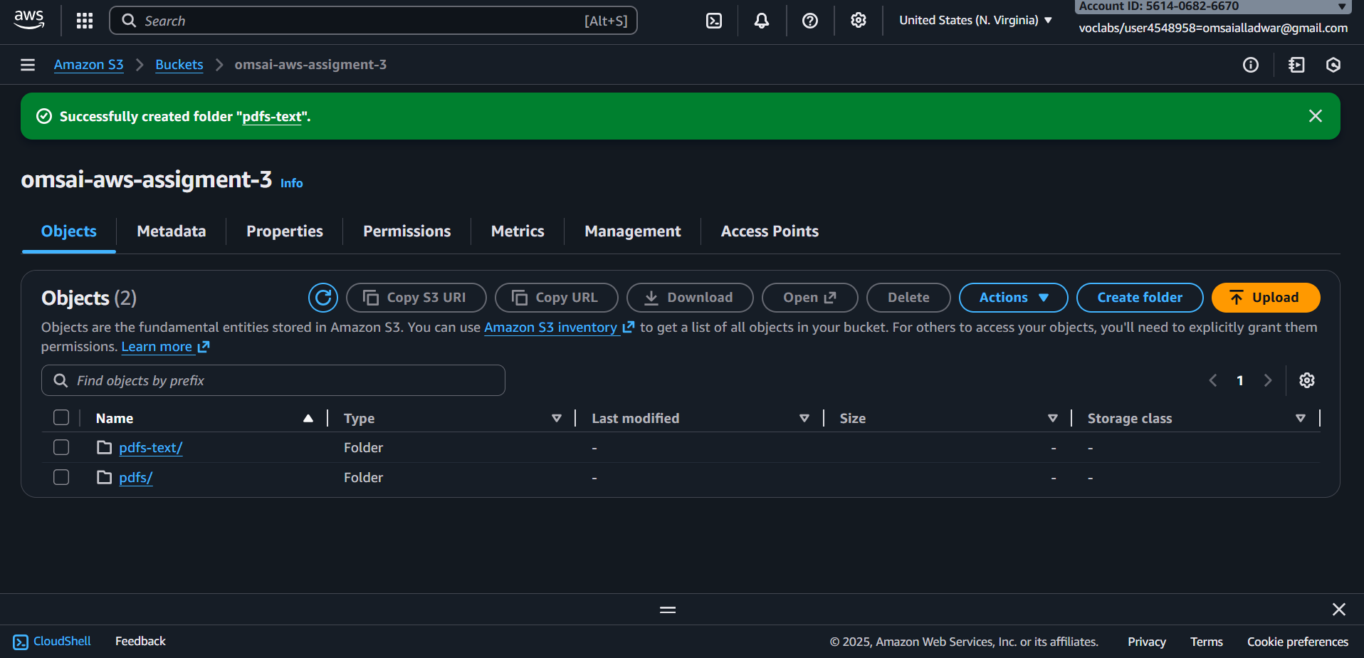

Created pypdf in lambda cloud shell

mkdir -p pypdf_layer/python
pip install pypdf -t pypdf_layer/python
cd pypdf_layer
zip -r ../pypdf-layer.zip .
cd ..
ls -lh pypdf-layer.zip

created a lambda layer
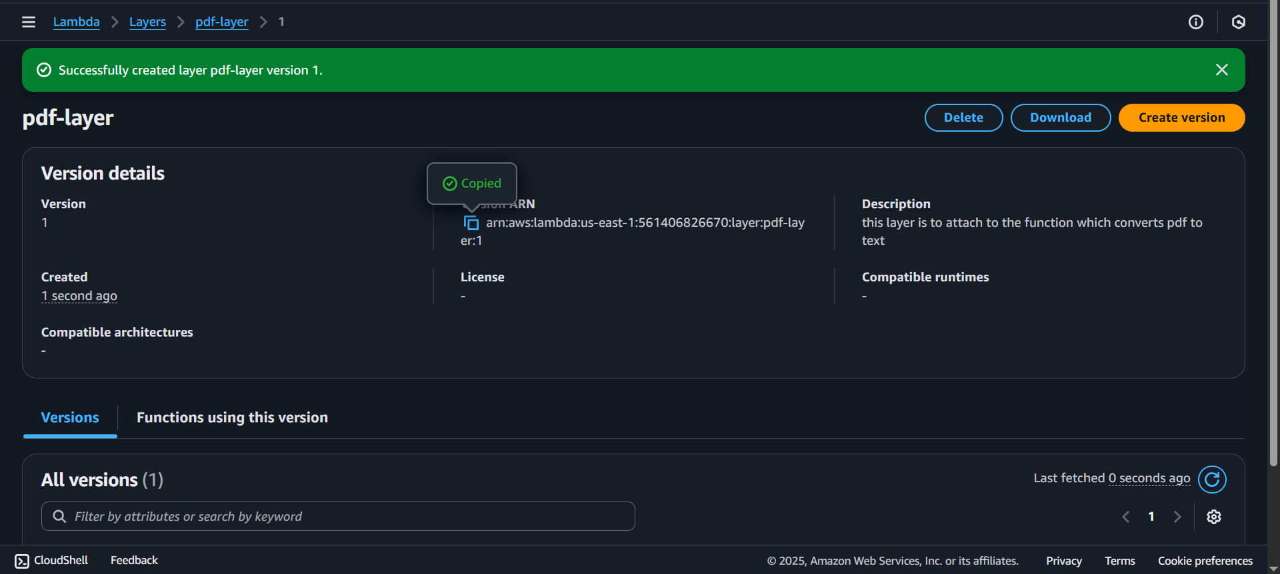

Added a function pdf-to-text
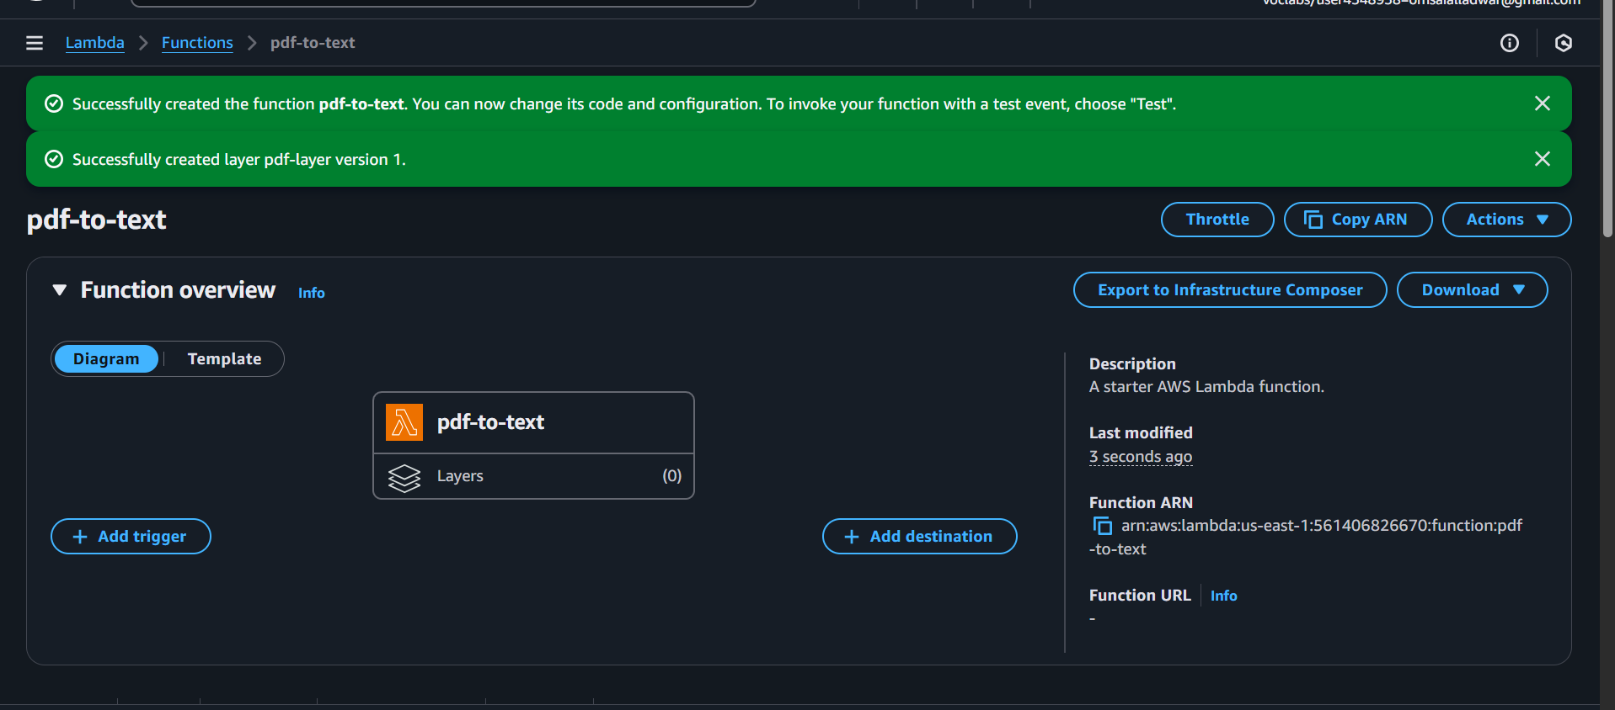

Added the layer to function
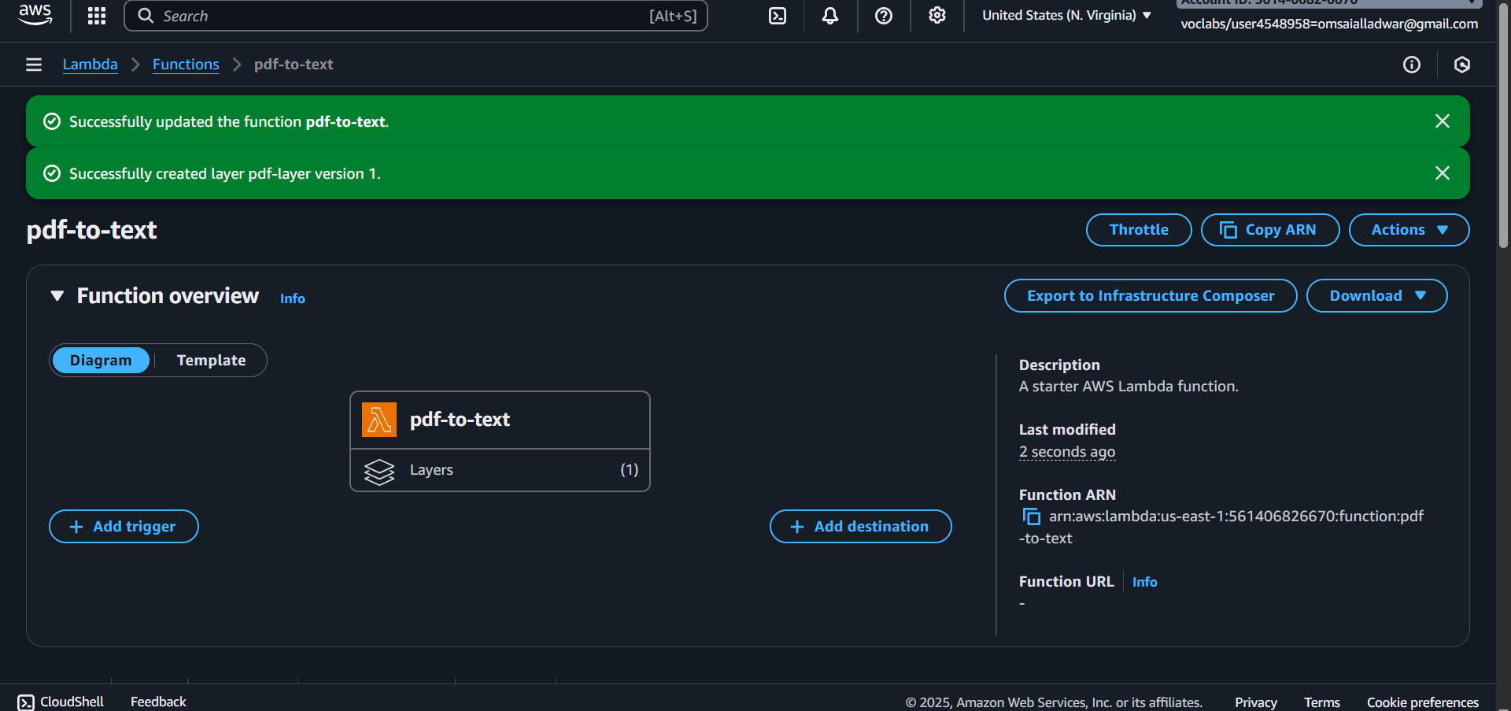

Added and deployed the code to lambda function
import os
import io
import boto3
from pypdf import PdfReader

s3 = boto3.client("s3")

def lambda_handler(event, context):
# expected S3 event
rec = event['Records'][0]
bucket = rec['s3']['bucket']['name']
key = rec['s3']['object']['key']

if not key.lower().endswith('.pdf'):
return {"status": "ignored", "reason": "not a pdf"}

# download PDF
resp = s3.get_object(Bucket=bucket, Key=key)
body = resp['Body'].read()

# read PDF with pypdf
reader = PdfReader(io.BytesIO(body))
texts = []
for page in reader.pages:
try:
texts.append(page.extract_text() or "")
except Exception as e:
# keep processing other pages
print("page extract error:", e)
texts.append("")

full_text = "\n\n".join(texts)

# prepare output key: pdfs-text/<origname>.txt
base_name = os.path.basename(key)
txt_name = os.path.splitext(base_name)[0] + ".txt"
out_key = os.path.join("pdfs-text", txt_name)

# upload extracted text
s3.put_object(Bucket=bucket, Key=out_key, Body=full_text.encode("utf-8"))

return {"status": "ok", "input": key, "output": out_key, "chars": len(full_text)}

added s3 event notification trigger from s3 bucket properties
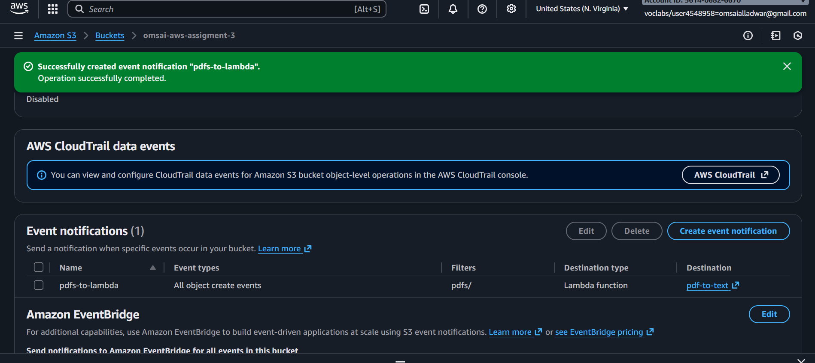

Added pdf to bucket/pdf/
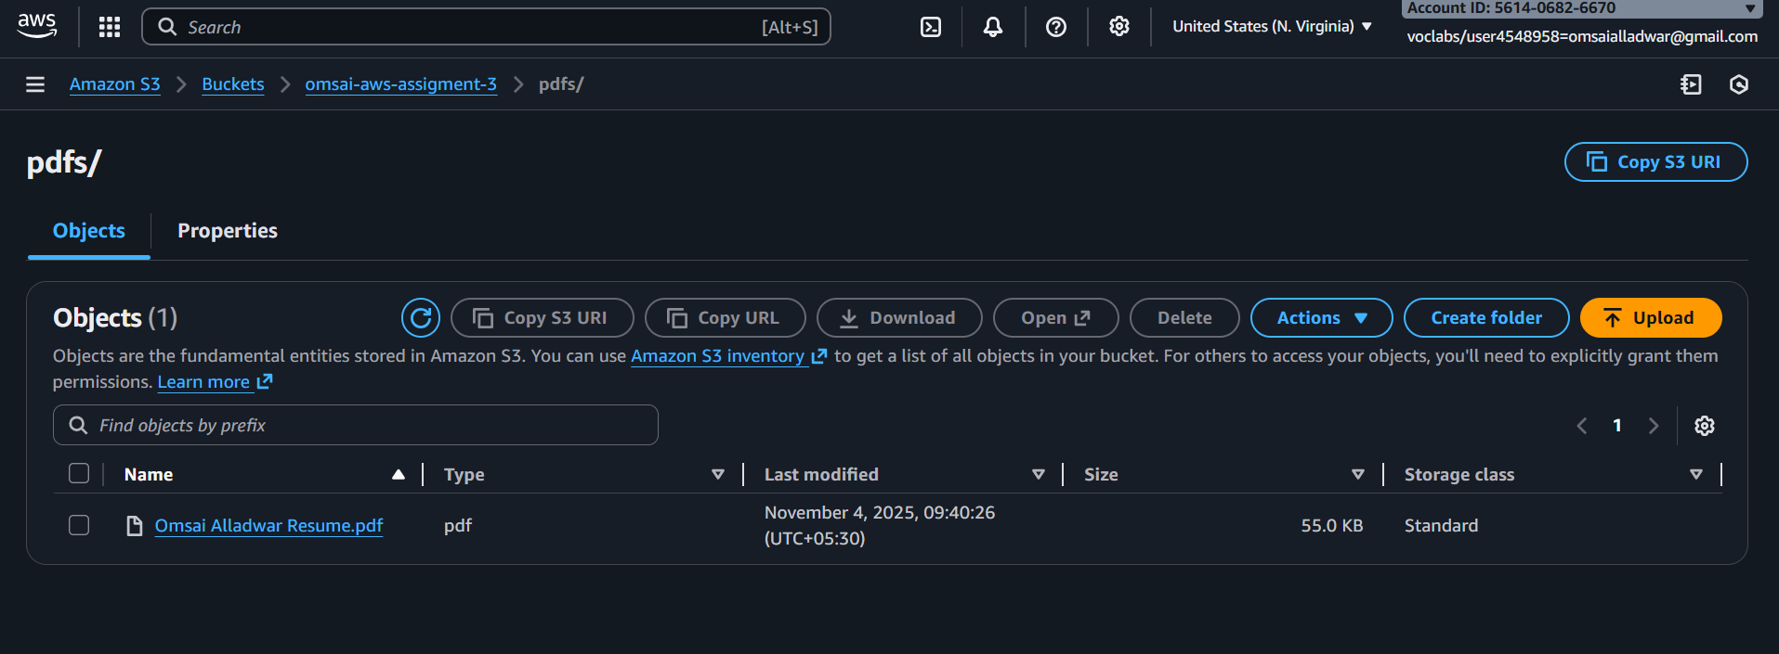

Pdf became txt
